User Guide 5 Request for Further Information
Purpose of this User Guide
The purpose of this User Guide is to provide assistance to Responsible Authorities, Applicant Contacts and referral authorities about how to request, respond and assess requests for further information.
Who should read this?
Primary audience: Responsible Authorities, referral authorities and Applicant Contacts
Introduction
During the application process, Responsible Authorities or referral authorities may require further information from the Applicant Contact to make their decision on planning permits or certification. This information can be requested through SPEAR, and for Responsible Authorities, a timeframe set for the response. The Applicant Contact is then prompted to respond to the request, which in turn prompts the requester (the Responsible Authority or referral authority) to assess the information they receive against their original request.
Applications where requests for further information from the Responsible Authority are not responded to within the specified timeframe may be lapsed by the Responsible Authority.
For referral authorities, the request for further information can be made at any time after a referral request has been received, or as part of a referral response to referrals under Section 55 of the Planning and Environment Act 1987, combined with a request to the Responsible Authority for a suspension of the statutory time clock.
SPEAR applications will not be able to progress through the planning process where there is an outstanding response to a request for further information action, or assessment of a response has not been completed. For example, the Responsible Authority will be unable to issue a planning permit decision until any current request for further information is completed.
5.1 How does a Responsible Authority request further information in SPEAR?
A Responsible Authority can request further information at any time after the application is accepted for lodgment.
From the Details tab, select the optional action from the ‘Other Actions’ drop-down list ‘Add Request for Further Information’ and click ‘go’.
Click ‘Browse’ and attach your previously prepared request for further information document in PDF format or, type (or paste) the details of your additional information request into the field provided. SPEAR will create a PDF document for you from this text.
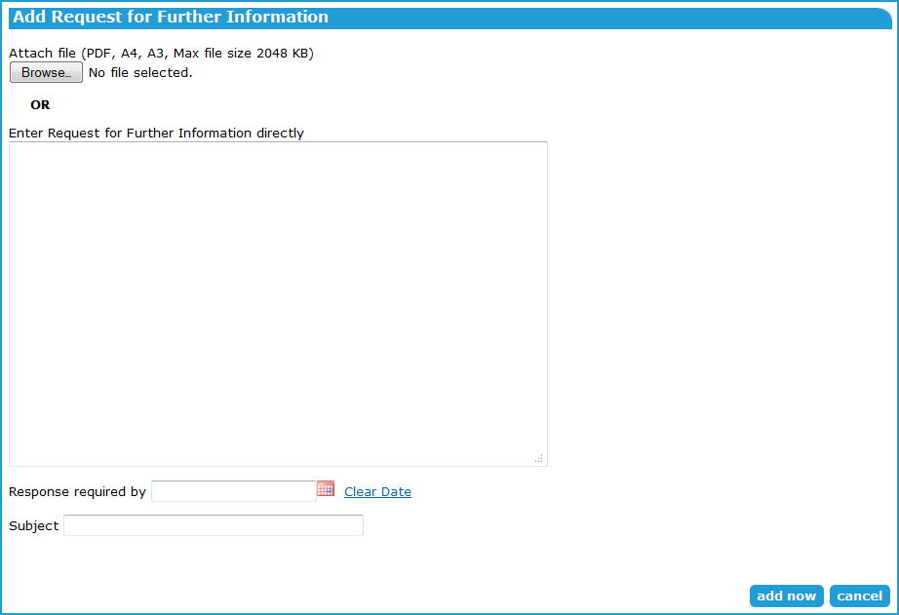

You must select the date which the Applicant Contact must respond by with the required information and provide a descriptive subject name for your request. Click ‘add now’.
Once the document is authenticated, an email notification is sent to the Applicant Contact notifying them of the request. The Applicant Contact will now have a mandatory action to respond to the Responsible Authority's request.
Requests for further information can be withdrawn by selecting ‘Withdraw’ from the drop-down box to the right of the document and clicking ‘go’. Withdrawing a request will remove the mandatory action for the Applicant Contact to respond to that request, thus allowing the application to proceed.

5.2 How does a Referral Authority request further information?
Requests for further information (RFI) occur as part of the response to a referral request. This method also sends a notification to the Responsible Authority to request a suspension of time on the statutory clock.
1. From the Details tab, select the mandatory action ‘Add RA Response (Section 55)’.
NOTE: If the application has been referred under Section 55 and certification and SOC, you will need to select the response to Section 55 and click 'next>'. You may also respond to certification and SOC at the same time.
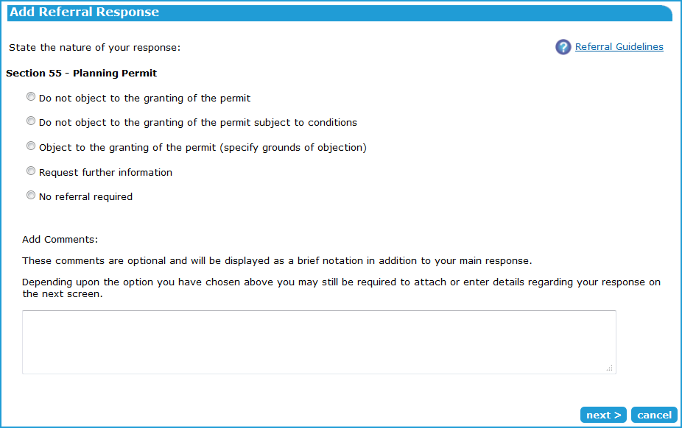
2. Select the option to ‘Request further information’ and click ‘next>’.

3. Click ‘Browse’ and attach your previously prepared response in PDF format, or
4. Type (or paste) the details of your response into the field provided. SPEAR will create a PDF document for you from this text. It is important to ensure that your contact details are included.
5. Once the document is authenticated, an email notification will be sent to the Applicant Contact notifying them about the request.
6. The Applicant Contact will now have a mandatory action to respond to the referral authority's request. Another notification will be sent to the Responsible Authority requesting a suspension of time for the statutory clock.
7. Once the response is added to SPEAR by the Applicant Contact, the referral authority will have a mandatory action to assess the response against the original request.
8. Responding to Section 55 remains a mandatory action for a referral authority and can be responded to at any time, even if the RFI has not been responded to by the Applicant Contact. If the referral authority chooses to respond ahead of receiving an RFI response from the Applicant Contact, the RFI is effectively cancelled.
5.3 How can an Applicant Contact respond to a request for further information?
Each request for further information from a Responsible Authority or referral authority will create a mandatory action for the Applicant Contact to respond to.
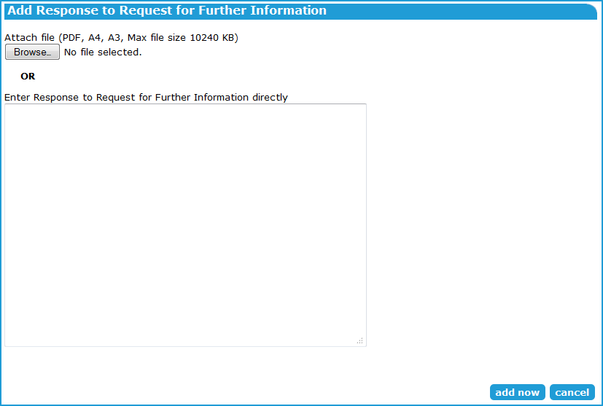
To respond, from the Details tab, click the mandatory action ‘Add Response to Request for Further Information’.

Click ‘Browse’ and add a previously prepared PDF document containing the additional information or, type (or paste) the details into the text box provided and SPEAR will create a PDF document from this text. Click ‘add now’.
Once the document is authenticated, it will be saved in SPEAR and an email notification sent to the Responsible Authority or referral authority notifying them of the response. The requester (Responsible Authority or referral authority) will now have a mandatory action to assess the Applicant Contact’s response.
Requests for further information made by a Responsible Authority will indicate the timeframe you have in which to respond. If you require additional time to collect the information you can request an ‘Extension of Time’ to respond to a request for further information.
NOTE: Further information requests made by referral authorities do not have a timeframe in which to provide a response in SPEAR.
5.4 Assessing the response to a request for further information.
When the Applicant Contact submits a response in SPEAR to a ‘Request for Further Information’, the requester (Responsible Authority or referral authority) will review the response.
If the request has not been satisfied, the Responsible Authority or referral authority will provide details of the outstanding requirements and the Applicant Contact will need to submit another response. If the due date for the further information has expired, the Responsible Authority may lapse the planning permit application.
If the request has been satisfied, the Responsible Authority or referral authority will proceed with the application.
5.5 How do Applicant Contacts request an extension of time to respond to a request for further information?
If the timeframe required by the Responsible Authority is not sufficient for the Applicant Contact to collect the relevant information, they can request that the Responsible Authority agree to an extension of time for the Applicant Contact to provide a response to a request.
- From the Details tab, select the optional action from the ‘Other Actions’ drop-down list ‘Request Extension of Time (subject)’ and click ‘go’.
- Click ‘Browse’ and attach your previously prepared extension of time request in PDF format or,
- Type (or paste) the details of your extension of time request into the field provided. SPEAR will create a PDF document for you from this text.

Enter the number of additional days you require to submit your response into the field provided. Click ‘add now’.
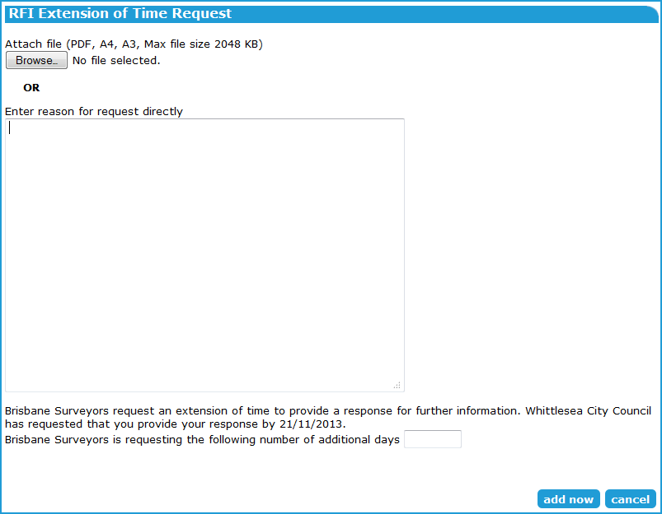
Once the document is added to SPEAR, an email notification will be sent to the Responsible Authority notifying them about the request for an extension of time. A mandatory action will be created for the Responsible Authority to ‘Assess Request For Extension of Time (subject)’ and they may accept or reject this request.
5.6 Assessing the request for an extension of time in response to a request for further information.
When the Applicant Contact submits a request for an extension of time to provide a response to a request for further information, the Responsible Authority must assess whether to grant the extension of time.
The Responsible Authority will have three options when assessing the request - accept (with no changes), accept (with change), or reject.
If the request is accepted (with no changes), the number of days requested by the Applicant Contact will be added to the current total of days allowed for the response. The due date for the response is displayed next to the Applicant Contact's mandatory action to respond to the request for further information.
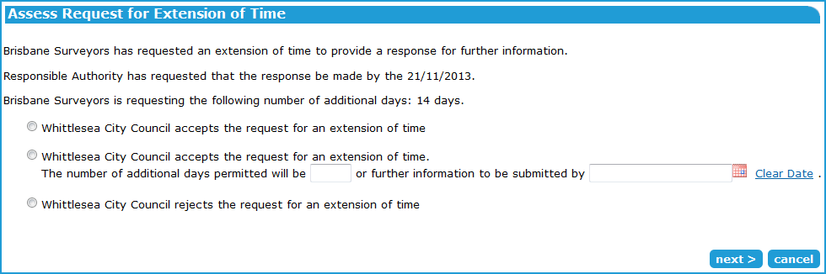
If the response is accepted (with changes), the Responsible Authority user must enter the number of ‘additional days permitted’, or select a ‘submitted by’ date into the field provided (see image below).

If the response is rejected, the response timeframe remains as it was.
After clicking ‘next’ the Responsible Authority must add a document to the decision by either clicking ‘Browse’ and attaching a previously prepared document in PDF format, or, by typing (or pasting) the details of the response into the field provided. SPEAR will create a PDF document for you from this text.
5.7 How does the Responsible Authority lapse an application that has exceeded the timeframe to respond to a request for further information?
The Responsible Authority can elect to ‘Lapse Application’ if the Applicant Contact has exceeded the allotted time frame to respond to a ‘Request for Further Information’. Once lapsed, the application is deemed to be complete and no further actions may be performed within the application.
From the Details tab, select the optional action ‘Lapse Application’ from the ‘Other Actions’ drop-down list and click ‘go’. You will be required to attach or enter a reason and then authenticate the decision.

Alternatively, as described in section 5.4 above, the Responsible Authority may lapse the application during the assessment of the Request for Further Information if the due date has expired.

Once completed, SPEAR sends notification emails to other interested SPEAR users, to advise them of the lapsing of the application in SPEAR. The status of the application changes to ‘Lapsed’. The documents and decisions previously added to a lapsed application are still available in SPEAR and are not deleted. Lapsed applications can be viewed from SPEAR user’s ‘completed Applications List’.
The ‘Lapse Application’ action is only available to the Responsible Authority once the prescribed time frame to respond to a Request for Further Information by the Responsible Authority has been exceeded.
If an application has been lapsed and needs to be restored, the Responsible Authority can select the optional action ‘Restore Lapsed Permit Application’ from the ‘Other Actions’ drop down list. A justification will be required prior to authenticating the decision. The application will be restored to its last processing state prior to being lapsed.
Once an application has been restored, SPEAR will send notification emails to all interested SPEAR users, advising them that the application has been reinstated. All available actions (mandatory and optional) will be restored for all users.
Need more information?
Further information on this topic can be found by:
- Visiting the SPEAR website www.spear.land.vic.gov.au/SPEAR
- Contacting the SPEAR Service Desk on 9194 0612 or email spear.info@delwp.vic.gov.au
- Selecting the Help link in the relevant area of the system.

